Steptoe School District #304 Reopening Plan Approved 8/17/20

Objective(s)

The goal of this plan is to provide a framework for the Steptoe School District to reopen for the 2020-2021 school year; following DOH, OSPI, and CDC guidelines around the Covid-19 Pandemic. The objectives are to:
- Provide the most effective educational opportunities for all students.
- Have all students safely attend our school.
- Partner with our communities to provide sound academic services

-------------------------------------

Primary Local Health Officer: Troy Henderson, Whitman County Health Office

District Level Point of Contact(s):

Eric Patton (Superintendent/Principal) / ericp@steptoe.k12.wa.us / (509) 397-3119

Cindy McCall (Nurse) / cmccall@lacrossesd.k12.wa.us / (509) 397-3119

Health/Screening Plan

Staff and students with any illness must stay home. Students and staff should be assessed for illness before attending school each day. Encourage parents to be on the alert for signs of illness in their children and to keep them home when they are sick. Screen children upon arrival, if possible.

The Department of Health states emphatically, that parents, should be attesting to their child's health and if they answer YES to any question, they should not be coming to school. If a child arrives at school without an attestation, then school staff will screen at the door.

Every day, ask staff, parents, guardians, and students (grades 6-8) to review the following questions and stay home if the answer is YES. (Appendix A)

            - Do you have any of the following symptoms that are not caused by another condition? (On the first day after a break or for a new student, please ask about the past 3 days 72 hours).

• Fever (100.4°F) or chills

• Cough

• Shortness of breath or difficulty breathing

• Unusual fatigue

• Muscle or body aches

• Headache

• Recent loss of taste or smell

• Sore throat

• Congestion or runny nose

• Nausea or vomiting

• Diarrhea

2. Have you been in close contact with anyone with confirmed COVID-19?

3. Have you had a positive COVID-19 test for active virus in the past 10 days?

4. Within the past 14 days, has a public health or medical professional told you to self-monitor, self-isolate, or self-quarantine because of concerns about COVID19 infection?

If a person believes or has been in close contact to someone with COVID-19, but they are not sick, they should watch their health for signs of fever, cough, shortness of breath, and other COVID-19 symptoms during the 14 days after the last day they were in close contact with the person sick with COVID-19. They should not go to work, child care, school, or public placers for 14 days.

Wearing cloth face coverings may help prevent the spread of COVID-19 and is required for staff and students. See the Washington State Department of health Guidance on Cloth Face Coverings and CDC Recommendations regarding the use of Cloth Face Coverings for more information. All individuals inside schools-Staff, Students, Parents, and other Visitors, will be required to wear Cloth Face Coverings as directed by DOH and Washington Department of Labor & Industries. There are limited circumstances under which individuals unable to wear a mask for health or behavioral reasons may instead wear a face shield.

For staff, cloth face coverings must be worn by every individual not working alone at the location unless their exposure dictates a higher level of protection under Department of Labor & Industries safety and health rules and guidance.
- Cloth face coverings should not be worn by:
      - Those with a disability that prevents them from comfortably wearing or removing a face covering.
      - Those with certain respiratory conditions or trouble breathing.
      - Those who are deaf or hard of hearing and use facial and mouth movements as part of communication.
      - Those advised by a medical, legal, or behavioral health professional that wearing a face covering may pose a risk to that person.
    - A physician’s note must accompany staff and/or students not wearing a mask and verified by the school nurse.
    - Students may use face shields as an alternative to a cloth face covering.
    - Younger students must be supervised when wearing a cloth face covering or face shield and will need help putting them on, taking them off, and getting used to wearing them.
    - Even when cloth face coverings are worn, continue to practice proper physical distancing.

Hygiene Practices

- Wash hands often with soap and water for at least 20 seconds.
- Children and adults should wash hands when they arrive at school, before meals or snacks, after outside time, after using the bathroom, after nose blowing or sneezing, and before leaving to go home.
- Try not to touch eyes, nose, or mouth with unwashed hands.
- Cover coughs and sneezes.

- Wearing a mask is mandatory while in the building (Students / Adults)

- Teacher completes log to submit to the office
- Student Wellness check including temperature

- Disinfect classrooms multiple times during the day.

-Maintain maximum physical distance from peers whenever possible (Social Distancing of 6 feet in the classrooms)

-Teachers will clean desks and seats at the conclusion of the day

-Parents/Caregivers
● Wearing a mask is mandatory while in the building (Students / Adults), please provide a mask for your student(s)

Teachers/Assistants
● All staff and students should be monitored for signs/symptoms of COVID-19 at the start of each day
- Staff sign-in at office
- Students checked by school staff
● Ensure classroom setup of desks provides physical distancing for students as much as possible
● Ensure students maintain physical distance
● Limit shared classroom materials.
● Keep the classroom door and windows open to maximize airflow and reduce the number of touches to
door handles.
● Use supplies provided to spray desks, chairs, and any common materials needed before
new students transition into the room

Custodians
● Make sure teachers are provided with all supplies needed daily including disinfectant and
paper towels.

Administration
● Ensure classroom seats are physically distanced as reasonably possible.
● Ensure classrooms are disinfected multiple times during the day.
● Ensure supplies are available for custodians and teaching staff.

COVID-19 Event Response (Appendix C)

We are developing a process, working in conjunction with the local health authority to quickly respond to any potential outbreak and to provide a safe environment for student/staff use.

● Student will be removed from class until they can be picked up by authorized person

● Local health authority will be notified and will advise on next steps

Return
● At least 3 days (72 hrs.) have passed since
recovery; AND

● At least 10 days have passed since signs first
showed. OR

● It has been at least 3 days (72 hrs.) since recovery AND a healthcare provider has certified that the student does not have suspected or confirmed Covid-19

● School Nurse/Health has confirmed
documentation

School Plan

The document we are now presenting includes some actions and prescriptions that are fairly certain or essential given our current state of knowledge and directions from OSPI and the DOH. In addition, this document will remain fluid and will change as evidence, expertise, and date demand. This return to School document is the first iteration of what will be a frequently changing work in progress over the next couple of months and throughout the next school year. Regulatory agencies at the federal, state, and local levels are adapting and modifying rules and guidance on an ongoing basis and may change our direction.

Drop-off and Pick-up Plan(s)

Drop-off | Pick-up
- 7:50 am Doors unlocked  - Main Entrance is the only one  open, all other doors are locked  Parents/Caregivers  ● Limit visits to school as much as possible: Parents/Guests are not allowed in the classrooms  ● Follow posted guidelines and read all signage  whenever entering the building.  ● Wear a mask and/or face shield when entering the building.  Students  ● Wear a mask or face shield when entering,  exiting, or moving around the building.  ● Use Sanitizing station upon entering building;  ● Report directly to your assigned classroom/area  upon arrival to school.  ● Maintain maximum physical distance from peers  whenever possible in hallways, common areas,  offices, etc. | - 2:55 Parents wait outside of building  Parents/Guests are not allowed in classrooms  - Wear a mask and/or face shield  - The building will be closed at 3:30 to the public

Staff Expectations

Teachers
● Supervise hallways and common areas to ensure students are reporting to assigned class and not
congregating in hallways or common areas.

Custodians
● Ensure designated doors are open at arrival and dismissal.
● Ensure designated doors are locked after arrival and dismissal.

Administration
● Ensure adequate supervision is available in hallways and in common areas
of the building.
● Ensure designated doors are open at arrival and dismissal.
● Ensure designated doors are locked after arrival and dismissal.
● Eliminate parent and community volunteers to ensure safety and health of students and
staff.
● Implement staggered dismissal times if necessary to maximize physical distancing and
student safety

Meals/Lunch/Snacks

Limit gatherings and potential mixing of classes or groups in the lunchroom and other communal spaces. Students will take their meals outside or eat in the classroom when possible.

Lunch
By Class
- Cold Lunch in lunchroom or outside
- Social Distancing appropriately (6 ft spacing)
- Rotating Lunch Schedule

Teachers/Assistants
● Supervise designated eating areas to ensure students are properly physically distanced.
● Monitor bathroom use during lunch time.

Cafeteria Staff
● Wear masks or face shields while serving food.
● Clean and disinfect serving areas, tabletops, and seats between lunches.
● Serve all food to students. (Students will not self-serve items as they have in the past.)

Administration
● Ensure proper signage is installed in designated eating areas.
● Implement staggered dismissal times if necessary to maximize physical distancing and
student safety

Instruction

Learning Platforms:
In person/Google Classroom,
- Google Meets and/or Zoom
- Grade appropriate printed materials
- Textbooks
- Online materials assigned by instructor

Attendance:
In-person: Attendance monitored daily using Skyward
Online: Teacher attendance log will be kept and submitted weekly to school office

Standards:
Adhere to Grade Level Standards for:
- ELA
- Math
- Science
- Social Studies
- PE/Electives?

Content standards established by OSPI (https://www.k12.wa.us/student-success/ learning-standards-instructional-materials)

Grading:
Elementary (K-5):
0-4
A-F

Secondary (6-8)
0-4
A-F
Incomplete: Students with incompletes are assigned to Support Classes with an instructor

Distance Learning Model

In the event of a delay, postponement, or cancellation, the following will guide staff in delivering online
instruction.
PK - 2; Paper packet with supplementary technology

3-8; Google Classroom
- Chromebooks will be assigned to students.
- Online video content for “on-demand” learning opportunity (Google Meets and/or Zoom)

Scheduled Class sessions via Google Meets and/or Zoom
- Attendance taken / Required

Special Ed / 504; Under Direction of Special Education Staff, may receive on campus as needed
Utilize staff for 1 on 1 and check in

Online video content for “on-demand” learning opportunity (Google Meets and/or Zoom)

Standardize technology (Computer with camera and microphone)

Classroom/Hallway/Common Areas

Parent/Caregiver Expectations
● Recommend providing your student with a clear water bottle daily to limit the use of water fountains.
● Provide your student with a proper face covering.

Students
● Report immediately to your designated area upon arrival to school.
● Follow all signage in the hallways, common areas and restrooms.
● Do not congregate in the restroom.

● Shared Hands-On Teaching Materials:
-Clean and sanitize hands-on materials often and after each use
-Limit shared teaching materials to those you can easily clean and sanitize or disinfect
-Books and other paper-based materials are not high risk for spreading the virus

● Hallway lockers will not be used.
-Students will transport their classroom material and supplies in their backpacks to their classroom.
-Locker rooms lockers will not be used for PE, students will not be required to suit down for PE.

Teachers
● Supervise hallways and common areas to ensure students are reporting to
class and not congregating in hallways or common areas.
● Assist in supervision of restrooms, hallways, and common areas between classes
● Supervise designated eating areas to ensure students are properly physically distanced. .

Custodians
● Disinfect common areas: This includes, but is not limited to, door handles, handrails, toilets, stalls, and sinks.
● Clean and disinfect serving areas, tabletops, and seats between lunches

Administration
● Ensure proper signage is installed in hallways and common areas.
● Ensure supplies are available for custodians.
● Implement measures such as closing sinks or urinals when necessary to allow for
appropriate physical distancing.
● Implement staggered dismissal times if necessary to maximize physical distancing and
student safety

Professional Development /Training

- Safeschools training on Covid-19 to go along with bloodborne pathogen and other training
- PD around distant learning
- SEL Training/monitoring for staff and students

Co-curricular/Extra-curricular Activities/Field-Trips/Assemblies

Every effort will be made to preserve the extra-curricular junior high athletics with Colfax School District which many in our community deeply care for. Athletics is also subject to public health requirements for physical distancing and cloth face coverings. Further guidance from OSPI, DOH, and Washington Interscholastic Athletics & Activities (WIAA) is forthcoming and will be incorporated into the overall school plan as we get additional information.

Steptoe School feels that field trips, assemblies, and other activities are essential to the learning process. Based on State and Local Guidance however, in-person activities and events such as field trips, assemblies, special performances, school-wide parent meetings, etc. will be suspended until the guidance changes and this information will be incorporated into the overall school plan as we get additional information.

Resources
- Consideration for Schools (CDC)
- Reopening Washington School 2020: District Planning Guide (OSPI)

Appendix A

PK – 8TH GRADE COVID-19 SYMPTOM CHECK LOG
Teacher Signature: ______________________________________ |  |  |  | Date: ____________________
Name | Date | Signs or Symptoms IF Covid-19 (Shortness of Breath, Cough, Sore Throat, Fever) | Contact with Covid-19 Positive Person (Circle One) | Temp | Notes
 |  | YES NO
 |  | YES NO
 |  | YES NO
 |  | YES NO
 |  | YES NO
 |  | YES NO
 |  | YES NO
 |  | YES NO

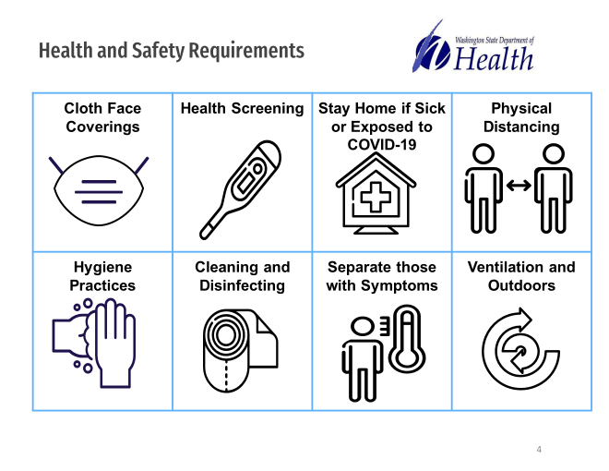
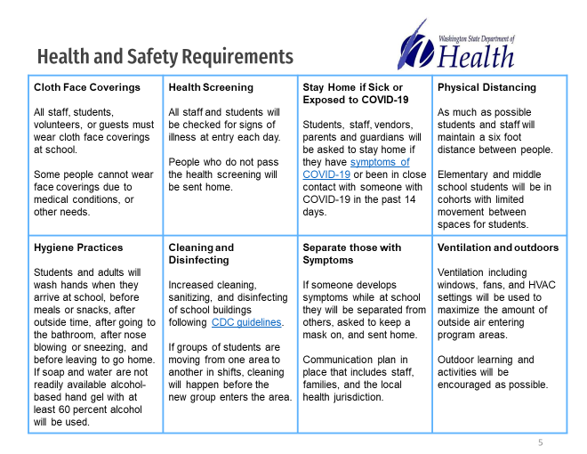
Appendix C
Hallways, Lockers and Common Areas
Student and Parent/Caregiver Expectations

Parents/Caregivers
● Recommend providing your student with a clear water bottle daily to limit the use of water fountains.
● Provide your student with a proper face covering.

Students
● Wearing a mask or face shield is required when in the school building.
● Report immediately to your designated area upon arrival to school.
● Follow all signage in the hallways and common areas.

Elementary School
●

Middle School
●

Appendix B
Hallways, Lockers and Common Areas
Student and Parent/Caregiver Expectations

Parents/Caregivers
● Recommend providing your student with a clear water bottle daily to limit the use of water fountains.
● Provide your student with a proper face covering.

Students
● Wearing a mask or face shield is required when in the school building.
● Report immediately to your designated area upon arrival to school.
● Follow all signage in the hallways and common areas.

Elementary School
●

Middle School
●

